Recording Form for Safeguarding Concerns
Staff or volunteers and regular visitors with a safeguarding concern are required to complete this form and pass it to the Designated Person for Safeguarding (Ruth Kemp) or Deputy Designated Person for Safeguarding (Kimberley Rayson).
Information Required | Enter Information Here
Full name of child or adult
Date of birth
Setting/place where incident/disclosure occurred
Your name and position
Nature of concern/disclosure
Please include where you were when the person made a disclosure/you became aware of a concern; what you saw; who else was there; what was said by both you and the person making the disclosure.
[Ensure that if there is an injury this is recorded (size and shape) and a body map is completed if appropriate]
[Make it clear if you have a raised a concern about a similar issue previously]
Time and date of incident:

Name and position of the person you are passing this information to:
Your Signature
Time and date form completed
Time form received by DPS/DDPS
Action Taken by DPS/DDPS
Referral made to social care [yes/no, date and time]
Referral made to police [yes/no, date and time]
Referral made to other agency [yes/no, date and time, name of organisation]
Parents informed [yes/no, date and time]
Feedback given to child/adult making the disclosure
[yes/no, date and time]
Feedback given to person who recorded disclosure
[yes/no, date and time]
Further action agreed
Full Name of DPS/DDPS
Signature of DPS/DDPS and date of signing

Body Map- Young Child
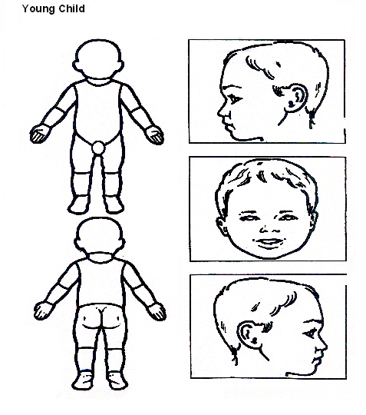

Indicate clearly where the injury was seen and attach this to the referral form

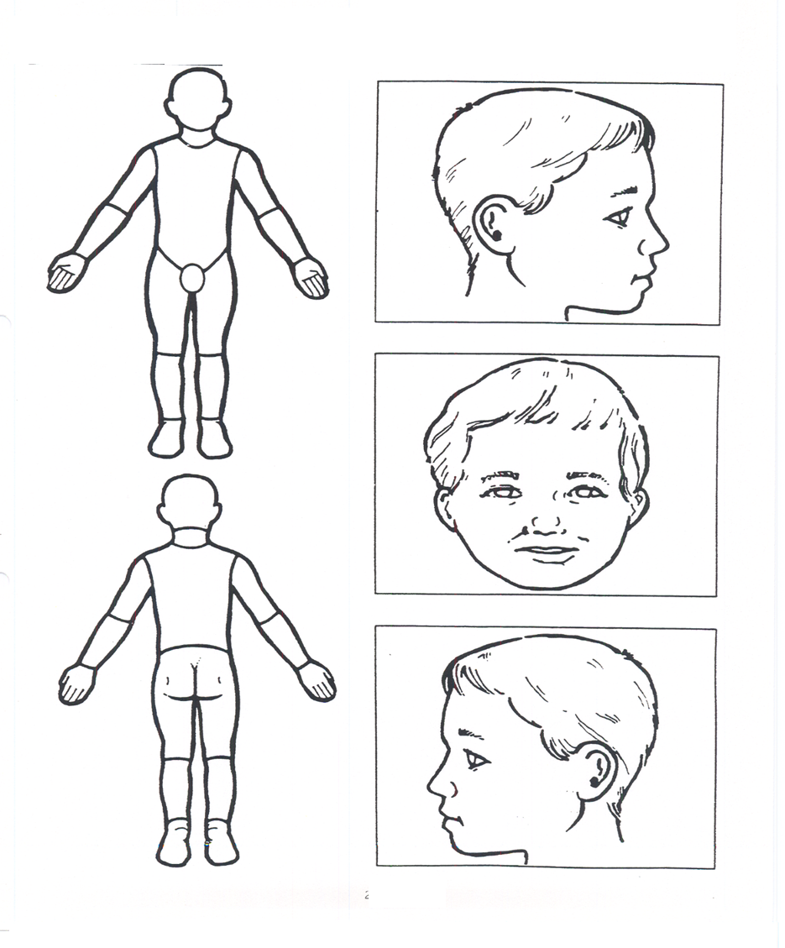
Body Map- older child

Indicate clearly where the injury was seen and attach this to the referral form

